**PHYSICAL EDUCATION-** **“BALANCING”**

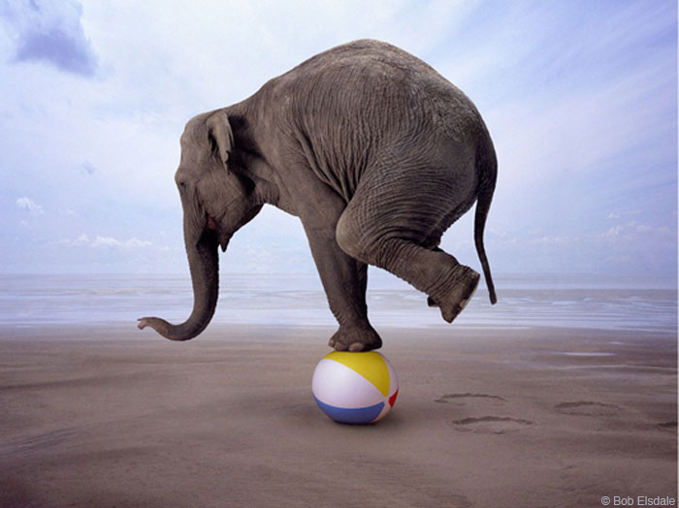

**Hi Everyone,**

**Today we will be working on balancing. We will not be balancing on things that are high. All the balances that we are going to practice will be on the ground! Here are some other words that will help you understand what balance means:**

**STEADY STABLE LEVEL EVEN**

**Let’s practice some simple balancing activities. You will not need anything but yourself for these.**

1. **Stand up straight with two feet on the ground. Try to balance on your right foot. Your right foot stays on the ground and try lifting your left foot off the ground. Now try to do it with your left foot on the ground and lift your right foot off the ground. Have someone time how long you can balance on each foot.**

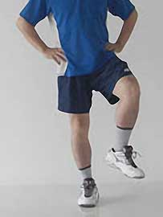 **RIGHT=______________ LEFT=____________**

1. **Find any line in your house on the floor or place a jump rope on the floor to walk across. You can also put a tape line down like in the picture below. Try to walk one foot in front of the other without falling off the line.**

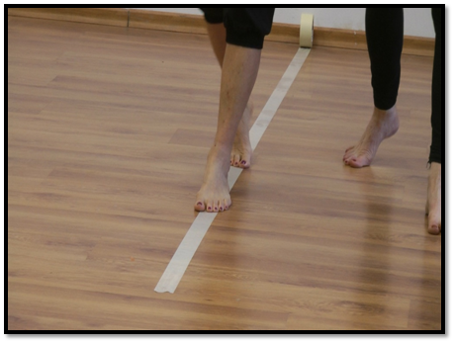

1. **We are now going to try to balance on our hands and feet at the same time! We are going to practice the crab walk! This is what it looks like. Our very own Liam and Mikayla are showing how it is done below! Try to do it without moving and then try to move!**

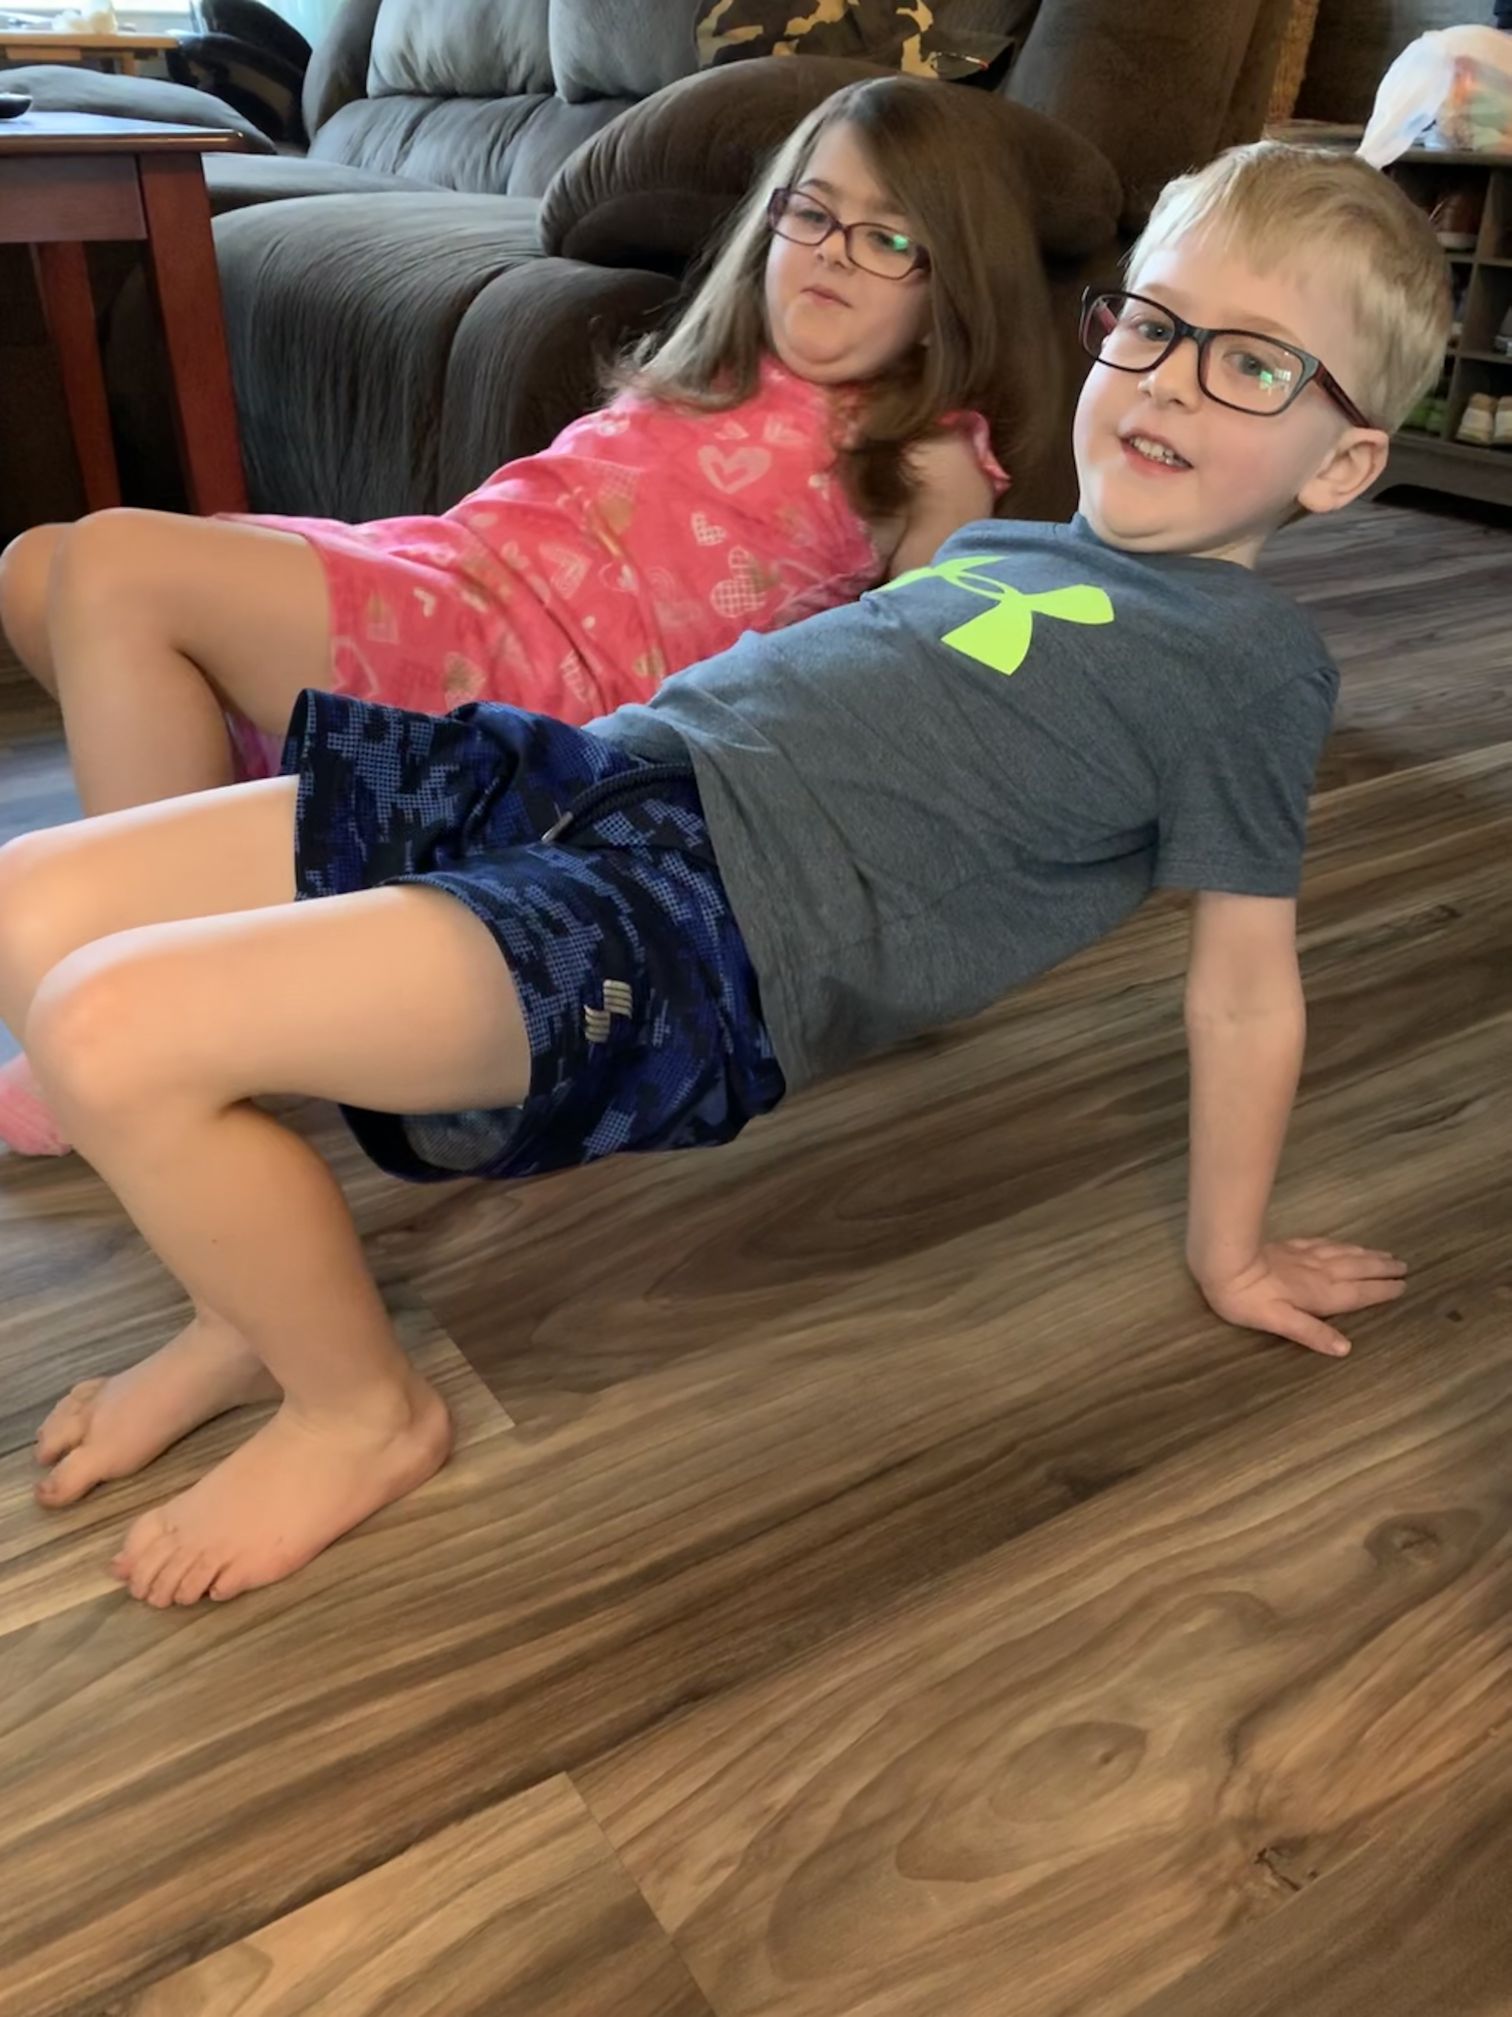

1. **We will now try to balance an object on our head and try to walk. Please choose a soft object such as a plastic frisbee, stuffed animal, bean bag or a book!**



**I hope you had fun with some of these balancing activities! Please email Mrs. Miller or Mr. Feiss or leave a message on School Story of Dojo when you have tried them!** [**MillerA@dvsd.org**](mailto:MillerA@dvsd.org) **or** [**FeissJ@dvsd.org**](mailto:FeissJ@dvsd.org)

**Take Care,**

**Mrs. Miller and Mr. Feiss** 